In summary, the proposed application work as follows:

* The patients, doctors, or any other users can access the website,
* Fill the form with patient’s diabetes information, then this form communicates with pre-trained model (proposed efficient machine learning algorithms in this paper) with using the flask sever.
* The report or the result appears to the user without any knowledge about machine learning, or programing.
* Finally, any user doesn’t have any data science experience, or any medical knowledge can use the website to determine the patient status. This section shows that how the technology facilitate the patient’s life, and minimize their pain. Figures 3 and 4 show real demo for predicating diabetes status of the patient through entering patient’s data to the proposed application

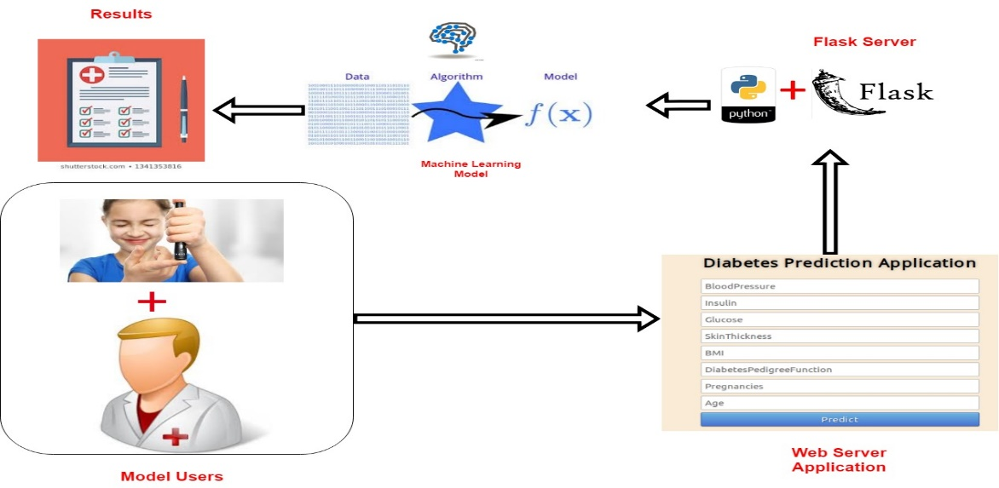

**Figure 1:** Proposed Web based diabetes prediction application using Flask.

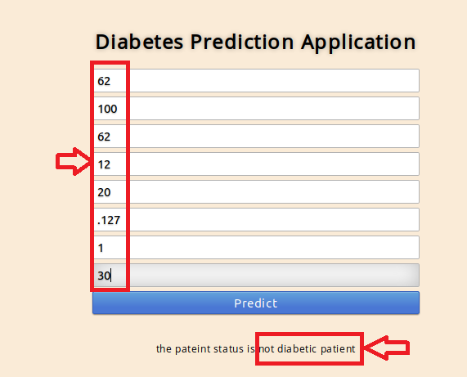

**Figure 2:** Results of predicting non diabetic status from patient’s data

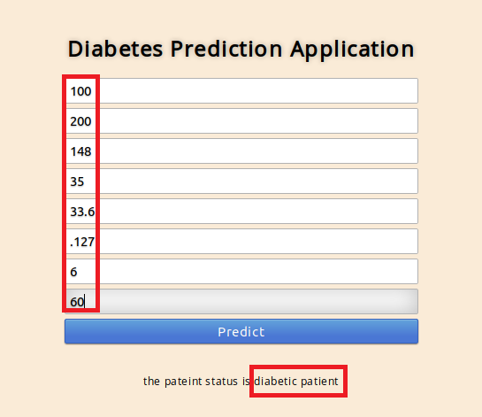

**Figure 3:** Results of predicting diabetic status from patient’s data